**Fictional website**

**Table of Contents**

1. **Introduction**1.1. Name and Student Details  
   1.2. Module  
   1.3. Fictional Website Overview
2. **Business Overview**2.1. Website Name: Lift Kings  
   2.2. Type of Business  
   2.3. Services Offered
3. **Target Audience**
4. **Website Goals**
5. **Common Problems Fitness Websites Face**
6. **Proposed Improvements**6.1. Layout and Design  
   6.2. Navigation  
   6.3. Mobile-Friendly Interface  
   6.4. User Tools
7. **Website Features & Functionality**7.1. Home Page  
   7.2. About Us Page  
   7.3. Products and Services Page  
   7.4. Enquiry Page  
   7.5. Contact Page
8. **Programming Languages and Frameworks**8.1. Current Development  
   8.2. Future Enhancements
9. **Project Timeline & Key Milestones**
10. Estimated Budget
11. **Additional Features**11.1. BMI Calculator  
    11.2. Progress Tracker  
    11.3. Weekly Blog
12. **Pictures Used**12.1. Gym Instructors  
    12.2. Gym Equipment for Sale  
    12.3. Gym Products for Sale
13. **References list**

**Name:** Itumeleng

**Surname:** Mashabela

**Student Number** : ST10478790

**Module**: Web Development

**Fictional website**

**2) BUSINESS OVERVIEW**

**Name: Lift Kings  
Type: personal fitness and coaching services**

1)Individual fitness training sessions, in-person or remotely

2) customized meal planning

3)exercise instructions

4) physique progress monitoring

**3 )Target Audience**

1) disciplined adults willing to improve their health

2)people who prefer online coaching

3)beginners who are looking for instructions and support

.

**4) Website Goals**

1. **gain new clients** – by implementing a Morden and user friendly website to attract fitness enthusiasts and beginners
2. **make bookings simple** – simplify the process for booking training sessions
3. **share useful resources** – provide valuable meal plans , workout plans, and results of hard working clients
4. **Support our clients** – help members keep track of their journey by providing BMI calculator , and digital motivational quotes

**5) Common Problems Fitness Websites Face**

1. **outdated interface**

- outdated fonts and contradicting colors

- Poor quality images

1. **Difficult to navigate**
   * + Website has a poor structure
2. **not mobile-friendly**
   * + Website looks poor on phones

**6 )Proposed Improvements**

1. **simple and tidy layout**

- Good quality images and clean color scheme

1. **Easy Navigation**

-Clear menu: *Home , About Us, products and services, Enquiry, Contact*.

1. **Phone-friendly interface**

-Website that looks good on all devices.

1. **User Tools**

- Diet planner – user types in fitness goals and the system will generate a diet plan

- Exercise Database – video exercise tutorials.

**7 . Website Features & Functionality**

**Home Page**

* Welcomes users with the Gym logo
* Features a button to book a free consultation and a explore training program button

**About Us Page**

* Presents the Lift Kings brand

**Products and Services Page**

-Presents the Products and equipment that we have for sale

-Highlights our training programs

**Enquiry page**

-This page lets users contact the gym.

**Contact page**

-Presents the gyms email and address **8 Programming Languages and Frameworks**

**Current Development:**

-HTML (used for building the structure of the site).

* **Future Enhancements:**

-CSS – for styling and layout.

-JavaScript – for interactive features (BMI calculator, progress tracker).

**9 Project Timeline & Key Milestones**

* **Part 1 – Initial Structure (by 27 August 2025)**

-Create basic HTML pages: Home, About, Services, Contact

-Set up navigation menu

-Add placeholder content and images

-Ensure responsive layout for devices

* **Part 2 – Styling & Interactivity (by 26 September 2025)**
* **Part 3 – Testing & Launch Preparation (TBD)**

**10 Estimated Budget**

* **Website Development:** R15,000 – R25,000

-Offers a good quality design, fully responsive HTML/CSS layout, JavaScript features, and interactive tools like BMI calculator and progress tracker.

* **Hosting & Domain Name:** R3,000 – R5,000 per year

-Includes reliable premium hosting, SSL certificate, and unique domain registration

* **Maintenance & Updates:** R5,000 – R8,000 per year

-Includes consistent content updates, Safety updates, performance improvement , and Feature updates

**Total Estimated First-Year Cost:** R23,000 – R38,000

**11) Additional Features**

* BMI Calculator – Simple tool for users to check their health stats.
* Progress Tracker – Members log in and record workouts.
* Weekly Blog – Nutrition tips, workout advice, and motivation.

**12 )Pictures used**

Gym instructors



(Wray, 2023)



(Wallpapers.com, 2025)



(Wallpapers.com, 2025)

GYM Equipment for sale

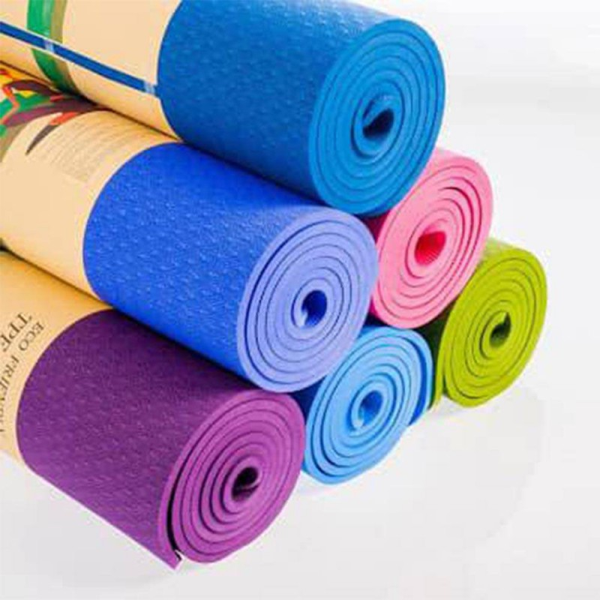

(Hirakraja, 2025)

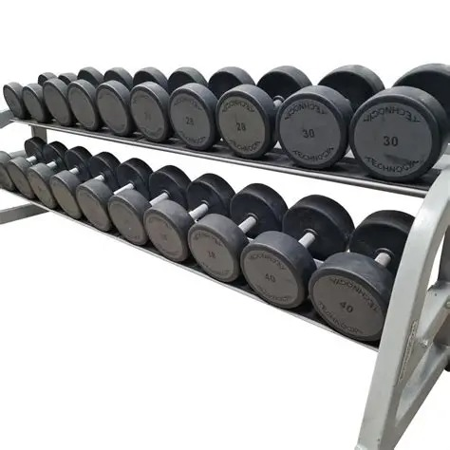

**(FitKit UK, 2025)**

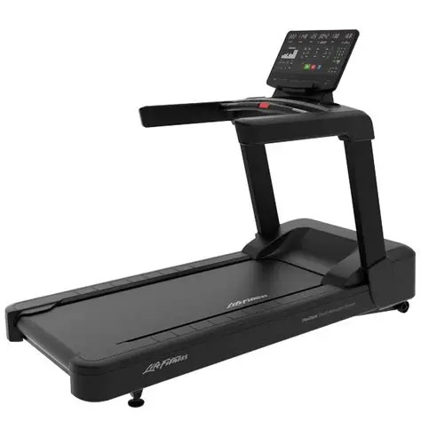

**(Life Fitness India, 2023)**

Gym products for sale

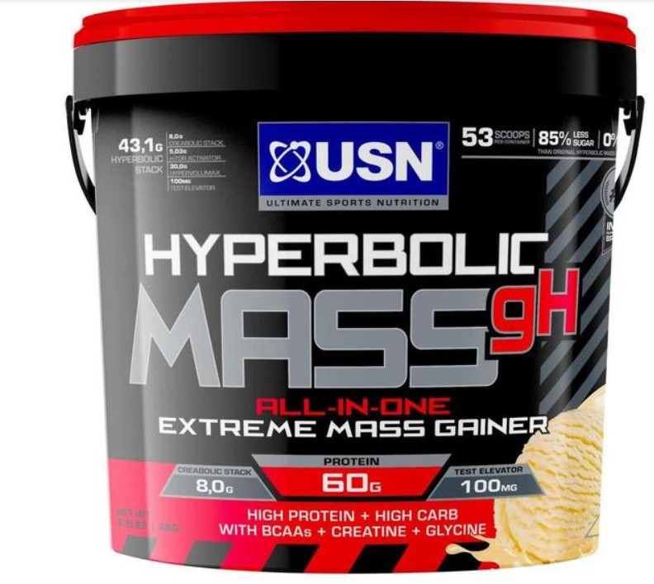

**(Reapp Ghana, 2024)**

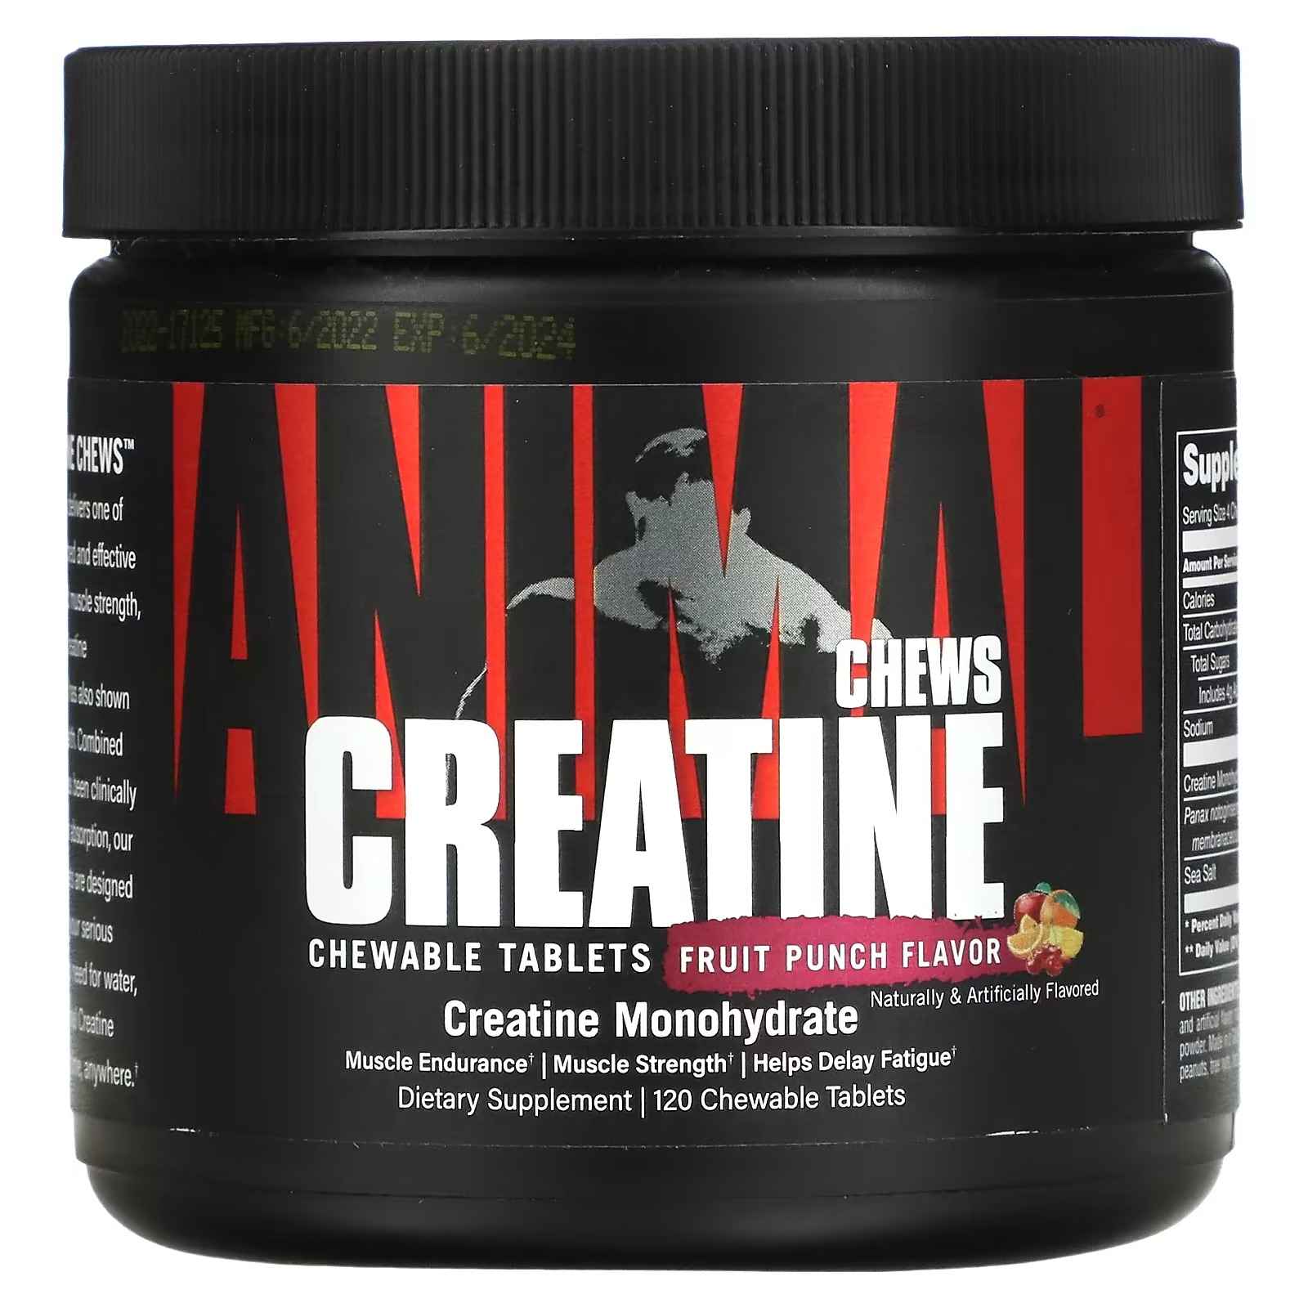

**(Animal, 2024)**

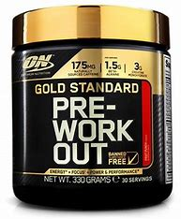

**(XXL Nutrition, 2024)**

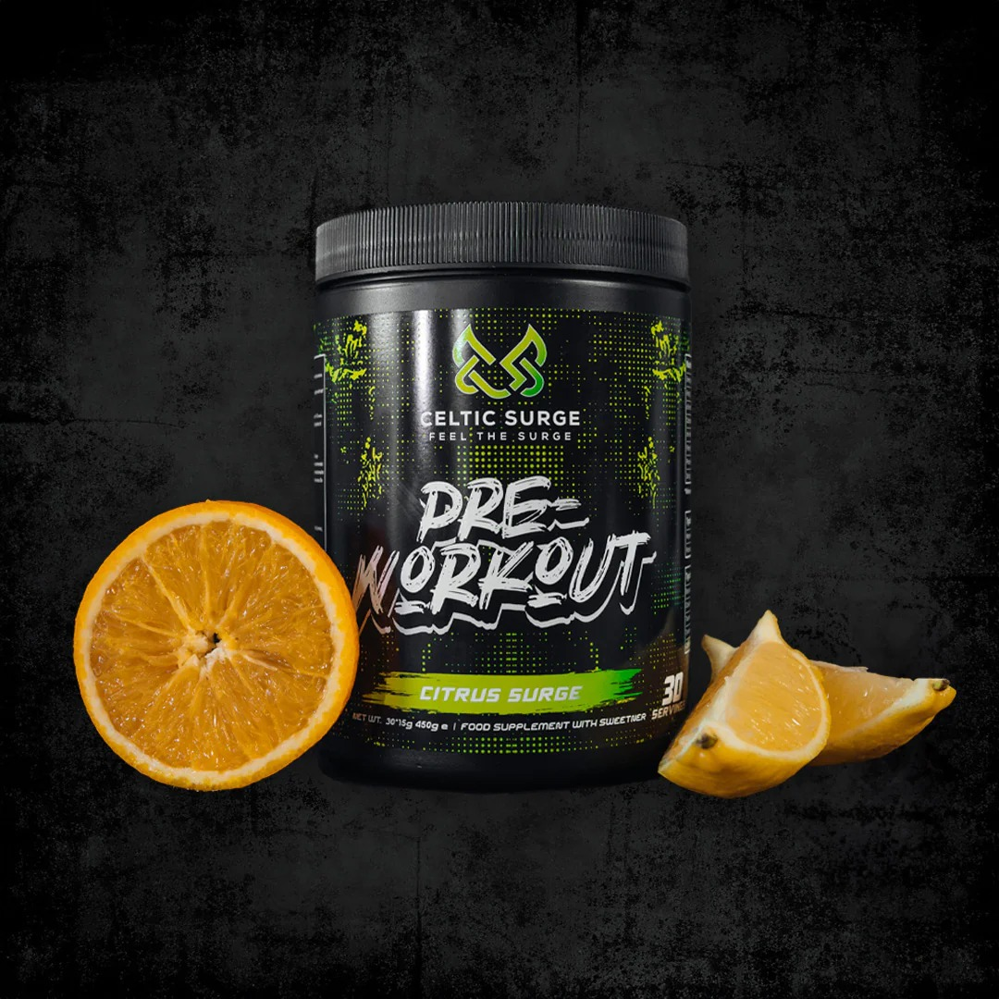

**(XXL Nutrition, 2024)**

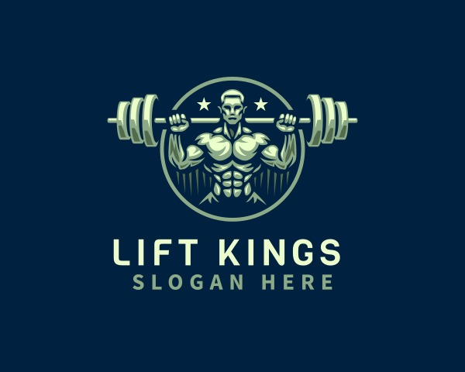

**(Design.com, 2025)**

**13) Reference list:**

**David Wray, 2023. *Ronnie Coleman: Bodybuilding Legend* [image online]. Available at:** [**https://www.lowkickmma.com/ronnie-coleman-bodybuilding-legend/**](https://www.lowkickmma.com/ronnie-coleman-bodybuilding-legend/) **[Accessed 22 August 2025].**

**FitKit UK, 2025. *Technogym Dumbbells 10kg–40kg Urethane Set with Racks* [ image online]. Available at:** [**https://www.fitkituk.com/strength-c2/dumbbells-c39/urethane-dumbbells-c68/technogym-dumbbells-10kg-40kg-urethane-set-with-racks-p4436**](https://www.fitkituk.com/strength-c2/dumbbells-c39/urethane-dumbbells-c68/technogym-dumbbells-10kg-40kg-urethane-set-with-racks-p4436) **[Accessed 22 August 2025].**

**Life Fitness India, 2023. *Aspire Treadmill SL Console – Smooth Charcoal* [image online]. Available at:** [**https://www.lifefitnessindia.com/wp-content/uploads/2023/06/aspire-treadmill-sl-console-smooth-charcoal.png**](https://www.lifefitnessindia.com/wp-content/uploads/2023/06/aspire-treadmill-sl-console-smooth-charcoal.png) **[Accessed 27 August 2025].**

**Hirakraja, 2025. *TPE Yoga Mat (8mm, 24" x 72") – Eco Friendly, Non-Slippery, Washable* [ image online]. Available at:** [**https://hirakraja.com/yoga-accessories/1266-tpe-yoga-mat-eco-friendly.html**](https://hirakraja.com/yoga-accessories/1266-tpe-yoga-mat-eco-friendly.html) **[Accessed 22 August 2025].**

**Wallpapers.com, 2025. *Sam Sulek Wallpapers* [ image online]. Available at:** [**https://wallpapers.com/sam-sulek**](https://wallpapers.com/sam-sulek) **[Accessed 22 August 2025].**

**Reapp Ghana, 2024. *USN Hyperbolic Mass Extreme Mass Gainer 4kg* [ image online]. Available at:** [**https://reapp.com.gh/usn-hyperbolic-mass-extreme-mass-gainer-4kg/**](https://reapp.com.gh/usn-hyperbolic-mass-extreme-mass-gainer-4kg/) **[Accessed 22 August 2025].**

**Animal, 2024. *Animal Creatine Performance Chews, Fruit Punch, 120 Chewable Tablets* [ image online].. Available at:** [**https://ie.iherb.com/pr/animal-creatine-performance-chews-fruit-punch-120-chewable-tablets/114847**](https://ie.iherb.com/pr/animal-creatine-performance-chews-fruit-punch-120-chewable-tablets/114847) **[Accessed 27 August 2025].**

**XXL Nutrition, 2024. *Pre-Workout* [ image online]. Available at:** [**https://xxlnutrition.com/nl/pre-workout?page=2**](https://xxlnutrition.com/nl/pre-workout?page=2) **[Accessed 22August 2025].**

**Design.com, 2025. Logo Maker [image online]. Available at:** [**https://www.design.com/s/logo-maker?code=25OFFSEM&utm_adgroup=_exact&utm_keyword=design.com&utm_network=o&msclkid=6a2b5a87e4e5195bd2d03228fb39eb31&utm_source=bing&utm_medium=cpc&utm_campaign=Africa:+01.+Brand&utm_term=design.com&utm_content=_Exact**](https://www.design.com/s/logo-maker?code=25OFFSEM&utm_adgroup=_exact&utm_keyword=design.com&utm_network=o&msclkid=6a2b5a87e4e5195bd2d03228fb39eb31&utm_source=bing&utm_medium=cpc&utm_campaign=Africa:+01.+Brand&utm_term=design.com&utm_content=_Exact) **[Accessed 22 August 2025]**